**IT5106 - Software Development Project**

**Project Proposal**

**Academic Year 2023**

**Candidate Details**

**Index No:**

2104581

**Name of candidate:**

R. D. D. Ganganath

**Address:**

No. 207,

Samagi Mawatha,

Walpola,

Ragama.

**Contact telephone numbers:**

0713313674

0707579674

**Email:**

dinuka.ganganathr@gmail.com

Supervisor/Advisor Details

|  |  |  |
| --- | --- | --- |
|  | Supervisor 1 (IT Related) | Supervisor 2 (Optional) |
| Name | A.H.P Jayaweera |  |
| Designation |  |  |
| Workplace address |  |  |
| Academic/  professional/  qualifications  and  memberships |  |  |
| Work experience |  |  |
| Email: |  |  |
| Phone number/s | 076 370 4119 |  |

Note: Any deviation of the final project from the project described in this proposal should be explained by the candidate in the final Project Report.

Project Details

1. **Title of Project:**

Sales, Purchase & Production Management System for "SAMPATH PRODUCTS"

1. **Name and address of client (ONLY if applicable):**

Sampath Products

No.503

Narangodapaluwa,

Batuwatta.

1. **Brief Introduction:**

***About Client:***

Sampath Products is a company that manufactures and distributes packets of **Biscuit powder** on a small scale in the area. It manufactures and distributes packets of various sizes following its own methods by procuring the required raw materials from a **few selected suppliers**. The primary targets for this are small **retail businesses and wholesale businesses** in the area. These buyers and suppliers are permanently identified.

***Current Business Process:***

Currently, this data and information flows into this business as follows.

*Supply Process:*

* The basic ingredients used for the products are bread and buns.
* There are three main types of ingredients.
  + Dry bread
  + Raw bread
  + Bun
* A few specific bakeries in the area are used to get them.
* The ingredients needed for a week are supplied at once.
* Prior notice should be given to the bakery three days prior to supplying the ingredients.
* About 100kg of ingredients are issued by one bakery at a time.
* For that, the specific prices mentioned earlier are used.

*Manufacturing Process*

* Products are sold in packs.
* Powder is made using bread ingredients.
* The powder is stored separately.
* The powder is used to make packets.
* Several predefined packet sizes are available.

|  |  |
| --- | --- |
| * 100 g | * 1 kg |
| * 250 g | * 5 kg |
| * 500 g | * 10 kg |

* Each of these packets has an expiration date and is issued in that order.

*Distribution and Sales Process*

* These products are sold to wholesale and retail stores.
* All orders are picked up before delivery and then transported using the company's own vehicles.
* All transactions are done in cash.
* New packets are exchanged for damaged packets.
* Products left after sale will not be accepted.

1. **Motivation for project:**

This company is currently being run completely manually. Due to the increase in the number of orders received and increase in demand, there is difficulty in store, handling data and information about the business. Basically, the following types of data can be identified in this business.

1. Data and information about **suppliers and supply process**.
2. Data and information related to the **manufacturing process**.
3. Data and information on product **distribution and sales**.

Due to the increase in the number of orders that are increasing day by day and the fact that this procedure is almost completely manual and not automated, many problematic situations arise.

* Lack of proper understanding of the quantities of raw materials required.

(In the current situation they have no any idea on what is the required quantity of biscuit powder, because the customer order management is very poor. So, they have no any proper idea how much of raw material they need to buy. Since this matter, sometimes the raw materials are going to be wastage or sometimes there may be a lack of raw materials.)

* Delayed errors in placing orders for raw materials

(With the current manual system, there is no any supplier management system. So, delaying for placing an order has become a common problem to the business. If the raw material ordering process is delayed, they cannot be able to collect raw materials at the wanted time. It will be the main reason for the production process and because of this matter sales and distributing process also can be delay.)

* Difficulty to keeping track of leftover biscuit powders to pack.

(The current system doesn’t have any method to keep a track of leftover packets. Then they haven’t any idea to how many packets to produce newly to fulfil the customer’s orders and how many packets they can be get from the stores for customer orders. Then they produce more than wanted and it will be another wastage. However, keeping some additional store is also an important and they are wishing to automate this process.)

* Expired packets left due to non-release of batches.

(When the store keeping and handling the stores, still they are using the manual process. Since, they are not using the batch processing method, they haven’t any idea on which batches are going to be expired in recent few days. Because of this matter, when they are distributing or selling the products, they are missed these expiring packets and it is a huge problem to the systems.)

* Lack of understanding about the quantities of products required for distribution.

(The current system of business has not any method to keep track to customer handling or customer order handling. Therefore, they are confused when distributing the products because if the number of orders ai higher, then they have to pay additional attention to check how much products should be manufactured for that purpose.)

* Absence of a specific, efficient system for accepting order.

(The distributing and selling process is mainly handled by sales persons of the business. They are getting the orders by using manual methods and keep their notes about the orders in separate books. So, analyzing and getting the summary of the orders is very hard to handle. With this system it should be corrected.)

To store and handle this data and information and to resolve these problems, it is expected to create a web application.

1. **Project Objectives**

The aim of this project is to help the existing business activities of the business by giving correct and efficient answers to the weaknesses mentioned above.

All the activities mentioned above are carried out by the following sections available in this application.

* Providing all the information to the user by logging into this application in a very short time.
* All data is stored transparently and accurately.
* Increasing the reliability of all transactions made.

**Supply Management Sub-System**

* Notifying when ingredients are low to a certain amount.
* Maintaining supplier details. Obtaining information about the cost of raw materials.
* Getting information about the number of raw materials needed for future products.

**Process Management Sub-System**

* To get an understanding of the existing prepared biscuit powder and the number of packets of each size.
* Knowing about the expiry dates of the currently remaining packets.
* To know about the total amount of packets required for orders and their quantity.
* Getting data about the value of each packet.

**Distribution and sales Management Sub-System**

* Taking notes on customer orders.
* Taking note of customer information.
* Recording information about the quantities of packets sold and the income.

1. **Scope of proposed project:**

**Supply Management Sub-System**

* + Supplier Management.
  + Purchase Order Management
  + Material Receive Note Management
  + Material detail and Inventory Management
  + Quotation Request Management.
  + Supply Payment Management

**Process Management Sub-System**

* + Material Analysis Management.
  + Production Order Management.
  + Product detail and Inventory Management

**Distribution and sales Management Sub-System**

* + Customer Management.
  + Customer Order Management.
  + Customer Invoice Management
  + Delivery Management
  + Payment Management

**Authentication and Authorization Management**

* + User Management.
  + Privileges Management.

1. **Critical functionalities for project:**

* Authentication and Authorization Management
* Purchase order management.
* Material Analysis Management.
* Production Order Management.
* Customer Invoice Management
* Material Receive Note Management

1. **Itemized list of deliverables of the system:**

Note: Deliverables are items that you would deliver to the client at the end of the project.

* User Manual
* Software tools to help maintenance of the code
* Fully Functional System (Fully Responsive Web Application)
* Analysis and design documents
* Source codes
* Test case document results document

1. **A project plan using Gantt chart (include the work involved in system development as well as writing the Final Project Report):**

Task List

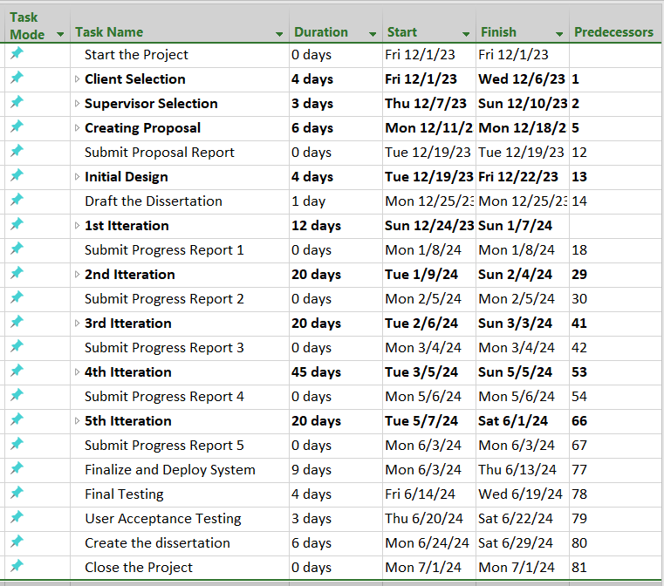

Gantt Chart

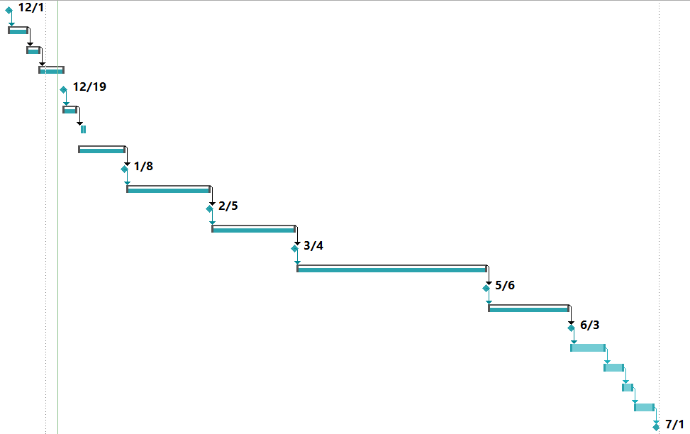

Full chart

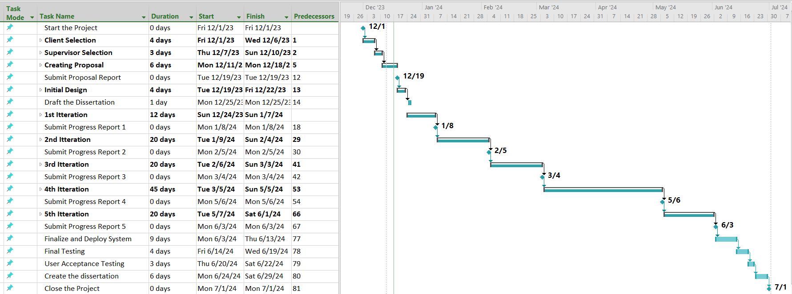

Detailed view of an Iteration

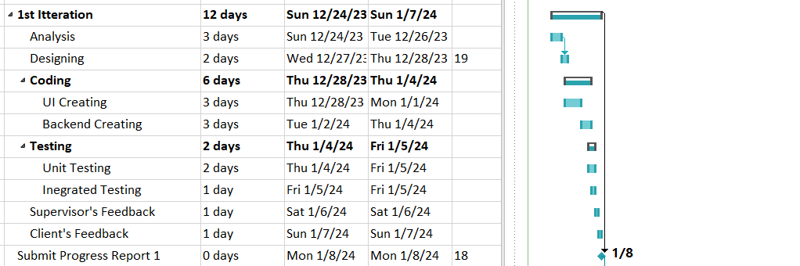

1. **Resource requirements for project (e.g., hardware, software,...)**:

*Software*

* + Visual Paradigm – For drawing UML diagrams
  + Microsoft Project – For drawing Gantt charts
  + Microsoft Visual Studio Code – For coding purposes
  + JDK 17 (Java 17) – For compiling Spring Project
  + MySQL Workbench – Managing Database
  + Any Web Browser (Google Chrome) – Visualizing the User Interface of System

*Hardware*

Machine with,

* Operating System – Windows 10 or upper
* Processor - Intel Core i5
* Ram - 8.00 GB
* Storage – 256 GB

1. **Proposed way of self-evaluating the success of your system:**

* The system will be developing with an Iterative Methodology.
* Each and every Iteration, meeting will be held between the supervisor as well as the client.
* Following two documents will be created and updated the project progress day-to-day until the project will be ended.

***Module Progress Record***

(When the tasks have completed the cell will be colored with specific color)

|  |  |  |  |  |  |  |  |  |
| --- | --- | --- | --- | --- | --- | --- | --- | --- |
| **No** | **Module** | **ER** | **Select** | **Insert** | **Update** | **Delete** | **Print Table** | **Row Print** |
| 1 | Material |  |  |  |  |  |  |  |
| 2 | Supplier |  |  |  |  |  |  |  |
| 3 | Quatation Request |  |  |  |  |  |  |  |
| 4 | Quatation Management |  |  |  |  |  |  |  |
| 5 | Purchase Order |  |  |  |  |  |  |  |
| 6 | Material Receive Note |  |  |  |  |  |  |  |
| 7 | Supply Payment |  |  |  |  |  |  |  |
| 8 | Product |  |  |  |  |  |  |  |
| 9 | Product Material |  |  |  |  |  |  |  |
| 10 | Product Batch |  |  |  |  |  |  |  |
| 11 | Product Order |  |  |  |  |  |  |  |
| 12 | Customer |  |  |  |  |  |  |  |
| 13 | Customer Order |  |  |  |  |  |  |  |
| 14 | Customer Invoice |  |  |  |  |  |  |  |
| 15 | Area |  |  |  |  |  |  |  |
| 16 | Sales Rep |  |  |  |  |  |  |  |
| 17 | Deliver Vehicle |  |  |  |  |  |  |  |
| 18 | Payment |  |  |  |  |  |  |  |
| 19 | Dasboard |  |  |  |  |  |  |  |
| 20 | Sign up |  |  |  |  |  |  |  |
| 21 | Log in |  |  |  |  |  |  |  |
| 22 | Privilages |  |  |  |  |  |  |  |
| **Report Generating** | | | | | | | | |
| 23 | Prouction Report |  |  |  |  |  |  |  |
| 24 | Sales Report |  |  |  |  |  |  |  |
| 25 | Customer Order Report |  |  |  |  |  |  |  |
| 26 | Daily Income Report |  |  |  |  |  |  |  |

***Iteration Progress Record***

(Completed Date will be marked when task ended.)

|  |  |  |  |  |
| --- | --- | --- | --- | --- |
| **Iteration** | **Module** | **Completed Date** | **Supervisor meeting** | **Client Meeting** |
| 1 | Material |  |  |  |
| Supplier |  |
| Quatation Request |  |
| Quatation Management |  |
| 2 | Purchase Order |  |  |  |
| Material Receive Note |  |
| Supply Payment |  |
| 3 | Product |  |  |  |
| Product Material |  |
| Product Batch |  |
| Product Order |  |
| 4 | Customer |  |  |  |
| Customer Order |  |
| Customer Invoice |  |
| Area |  |
| Sales Rep |  |
| Deliver Vehicle |  |
| Payment |  |
| Dasboard |  |
| Sign up |  |
| Log in |  |
| Privilages |  |
| 5 | Prouction Report |  |  |  |
|  | Sales Report |  |
|  | Customer Order Report |  |
|  | Daily Income Report |  |